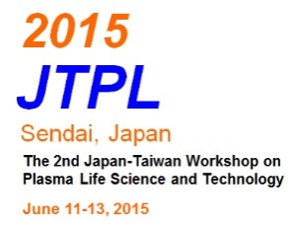2015 JTPL

The 2nd Japan-Taiwan Workshop on

Plasma Life Science and Technology

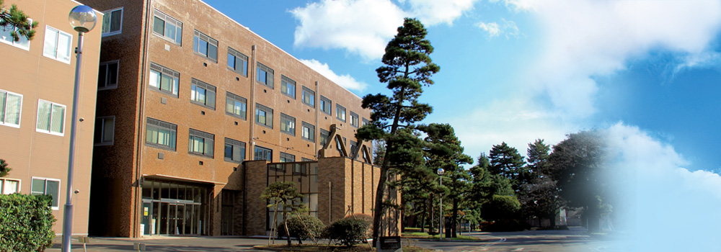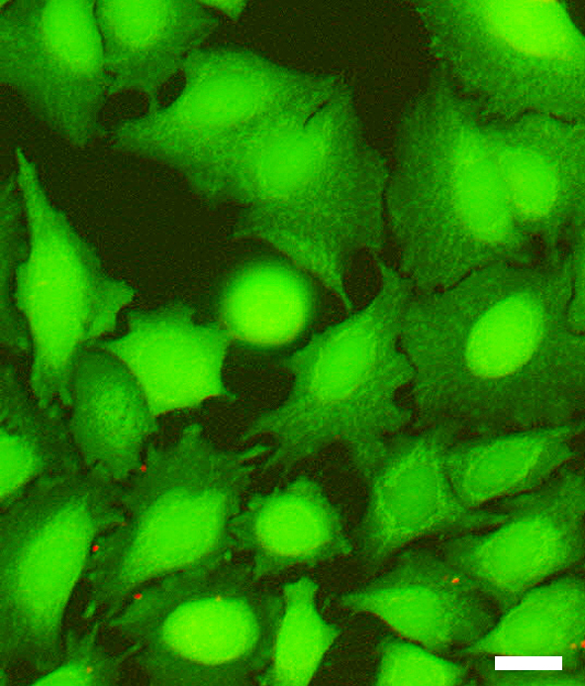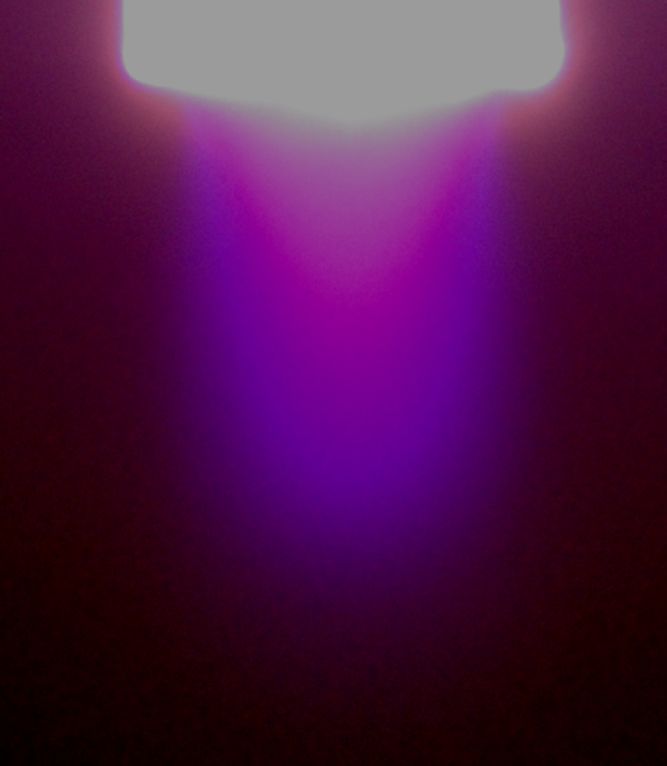

URL: http://www.ifs.tohoku.ac.jp/bionano/2015JTPL/2015JTPL_home.html

Scope

The 2nd Japan-Taiwan Workshop on Plasma Life Science and Technology will be held on June 11-13, 2015, at the Institute of Fluid Science (IFS), Tohoku University, hosted by the IFS and Graduate School of Engineering, Tohoku University. The first workshop was successfully held at National Chiao Tung University in Hsinchu, Taiwan on December 19-21, 2014 chaired by Professor Jong-Shinn Wu (National Chiao Tung University, Taiwan). The major focus of this bilateral workshop is to systematically cultivate potential academic collaboration between two countries by exchanging the latest advancement of research and development of plasma science and technology in the application of biomedicine, agriculture, food and others directly or indirectly related to life science. The workshop was also decided to switch between Japan and Taiwan each year from 2014 onwards.

Schedule

June 11-13, 2015 (June 11, Welcome party)

Venue

Institute of Fluid Science, Tohoku University

(2-1-1 Katahira, Aoba-ku, Sendai, 980-8577, Japan)

http://www.ifs.tohoku.ac.jp/eng/map.html

Scientific committee

Yun-Chien Cheng (National Chiao Tung University, Taiwan)

Toshiro Kaneko (Tohoku University, Japan)

Jang-Hsing Hsieh (Ming Chi University of Technology, Taiwan)

Cheng-Che Hsu (National Taiwan University, Taiwan)

Chia-Yung Lin (National Taiwan University, Taiwan)

Go Imada (Nigata Institute of Technology)

Yasushi Minamitani (Yamagata University, Japan)

Keh-Chyang Leou (National Tsing Hua University, Taiwan)

Koichi Sasaki (Hokkaido University, Japan)

Kohki Satoh(Muroran Institute of Technology, Japan)

Takehiko Sato (Tohoku University, Japan)

Koichi Takaki (Iwate University, Japan)

Meng-Jiy Wang (National Taiwan University of Science and Technology, Taiwan)

Ta-Chin Wei (Chung-Yuan Christian University, Taiwan)

Ming-Chang Wu (National Ping-Tung University of Science and Technology, Taiwan)

Jong-Shinn Wu (National Chiao Tung University, Taiwan)

Hiroyuki Yoshiki (Tsuruoka National College of Technology, Japan)

Organizing committee

Co-Chair

Takehiko Sato (Institute of Fluid Science, Tohoku University, Japan)

Jong-Shinn Wu (National Chiao Tung University, Taiwan)

Vice Chair

Toshiro Kaneko (Tohoku University, Japan)

Yasushi Minamitani (Yamagata University, Japan)

Koichi Takaki (Iwate University, Japan)

Hiroyuki Yoshiki (Tsuruoka National College of Technology, Japan)

Administrative Staff

Megumi Akama (Tohoku University, Japan)

Tomoki Nakajima (Tohoku University, Japan)

Plenary lecture

Taiwan side

Associate Prof. Cheng-Che Hsu (National Taiwan University, Taiwan)

Japan side

Prof. Koichi Sasaki (Hokkaido University, Japan)

Invited Speakers

Taiwan side

Prof. Yun-Chien Cheng (National Chiao Tung University)

Prof. Jang-Hsing Hsieh (Ming Chi University of Technology)

Prof. Keh-Chyang Leou (National Tsing Hua University, Taiwan)

Associate Prof. Ta-Chin Wei (Chung-Yuan Christian University)

Prof. Jong-Shinn Wu (National Chiao Tung University)

Japan side

Prof. Toshiro Kaneko (Tohoku University)

Associate Prof. Yasushi Minamitani (Yamagata University)

Prof. Kohki Satoh (Muroran Institute of Technology)

Prof. Takehiko Sato (Tohoku University)

Prof. Koichi Takaki (Iwate University)

Prof. Hiroyuki Yoshiki (Tsuruoka National College of Technology)

Prof. Kohki Satoh (Muroran Institute of Technology)

Abstract Submission

Guidelines for Abstract Preparation

1. Please refer to the Abstract Template to prepare your abstract.

Only abstracts that meet requirements will be considered for presentations.

2. All abstracts must be submitted in **English** and the maximum length is A4 one page.

3. Best Poster Awards for students will be selected from poster presentations and awarded in the awards ceremony. 3 minutes short oral presentation per poster is required.

*Deadline for abstract submission: May 18, 2015

Registration

Please send the registration form to akama@plasma.ifs.tohoku.ac.jp before deadline.

Registration: 10,000JPY (Invited and general participants),

Free (Student, Accompany persons)

Welcome Party: Free (All participants)

Banquet: Free (If a participant is not registered, the fee is 5,000JPY.)

Excursion (including dinner): 5,000JPY (All participants)

*Deadline for registration: May 11, 2015

Support

This workshop is partially supported by the Research Institute of Electrical Communication, Tohoku University.

Contact

General Information

Prof. Takehiko Sato

TEL&FAX: +81-22-217-5320

E-mail: sato@ifs.tohoku.ac.jp

Abstract & Registration

Ms. Megumi Akama

TEL&FAX: +81-22-217-5320

E-mail: akama@plasma.ifs.tohoku.ac.jp

Workshop program

June 11 (Thu)

IFS 1st Bldg., 2nd Floor, Multi-purpose room and Café room

17:00-19:00 Registration and Welcome Party

June 12 (Fri)

Room: IFS 1st Bldg. 2nd Floor, Meeting Room

8:30-9:00 Registration

9:00-9:10 Opening (Prof. Sato & Prof. Wu)

Session 1 (Chair: Y. Minamitani)

9:10-9:35 J.-S. Wu (National Chiao Tung University) *Invited*

Development of a Portable Cold Plasma Jet Device for Biomedical Application

9:35-10:00 Toshiro Kaneko (Tohoku University, Japan) *Invited*

Synergy Effects of Physical and Chemical Stimulations on Cell Membrane

Transport Using Non-Equilibrium Atmospheric Pressure Plasma

10:00-10:25 K.-C. Leou (National Tsin Hua University) *Invited*

Microwave Based Sensors for Process Monitoring and Feedback Control of Plasma Processing Tools

10:25-10:45 Coffee Break

Session 2 (Chair: J.-S. Wu)

10:45-11:25 C.-C. Jerry Hsu ((National Taiwan University) *Plenary*

Recent Progress on Atmospheric Pressure Plasma Development: From  
Ultra-Rapid Processing to Portable and Disposable Plasma Generation  
Devices

11:25-11:50 Kohki Satoh (Muroran Institute of Technology) *Invited*

Examining and Estimating Collision Cross Section Set of H2O Vapour for Reliable Plasma Simulation.

11:50-12:50 Lunch

Session 3 (Chair: K. Takaki)

12:50-13:15 Yasushi Minamitani (Yamagata University, Japan) *Invited*

Investigation of Difference of Origin of ROS Generated in a Cell by Frequency Components of Pulsed Electric Field

13:15-13:40 Yun-Chien Cheng (National Chiao Tung University) *Invited*

Effects of Cold Plasma on Human Dental Pulp Stem Cells

13:40-14:05 Hiroyuki Yoshiki (National Institute of Technology, Tsuruoka College) *Invited*

Inner Surface Treatment of Sealed Microchannels by Cold Microplasmas

14:05-14:25 Coffee Break

14:25-16:10 Poster Session (Chair: T.-C. Wei)

(2.5 minutes short oral presentation per poster, Presentation are scored by core members to choose Best Poster Awards)

16:30-18:30 Lab tour in IFS (Sato Lab and Shockwave center) and Kaneko Lab.

19:00-21:30 Banquet (Biwane)

June 13 (Sat)

Room: IFS 1st Bldg. 2nd Floor, Meeting Room

8:40-9:00 Registration

Session 4 (Chair: K.-C. Leou)

9:00-9:25 Koichi Takaki (Iwate University, Japan) *Invited*

Conformational Change of Bovine Serum Albumin by AC Electric Field for Keeping Freshness of Marine Products

9:25-9:50 Jang-Hsing Hsieh (Min Chi University of Technology) *Invited*

Mechanical properties, biocompatibility and antibacteria behaviors of TaO0.4N0.8 and TaO0.4N0.8-Ag thin films

9:50-10:10 Coffee Break

Session 5 (Chair: T. Kaneko)

10:10-10:50 Koichi Sasaki (Hokkaido University, Japan) *Plenary*

Phenomena Observed Around the Interface Between DC Helium Glow Plasma and NaCl Solution

10:50-11:15 Ta-Chin Wei (Chung-Yuan Christian University) *Invited*

Modification of PVDF Membranes with Mixed-charge Copolymers by Atmospheric-Pressure Plasmas for Mitigation of Biofouling

11:15-11:40 Takehiko Sato (Tohoku University, Japan) *Invited*

Responses of HeLa Cells Exposed to a Medium Treated by a Plasma Flow at Atmospheric Pressure

11:40-11:50 Award Ceremony

11:50-12:00 Closing

12:00-12:45 Lunch

Excursion

Tour in Matsushima Bay and Sushi Restaurant

12:45-21:00

*Please feel free to contact us if you have food allergies and other requests.

**Excursion**

**Tour in Matsushima Bay and Sushi Restaurant**

Let’s enjoy one of the best 3 views of Japan and culture!

**Matsushima Bay Cruising (Boat)**

**松島島巡り観光船企業組合ホームページhttp://www.matsushima.or.jp/route/**

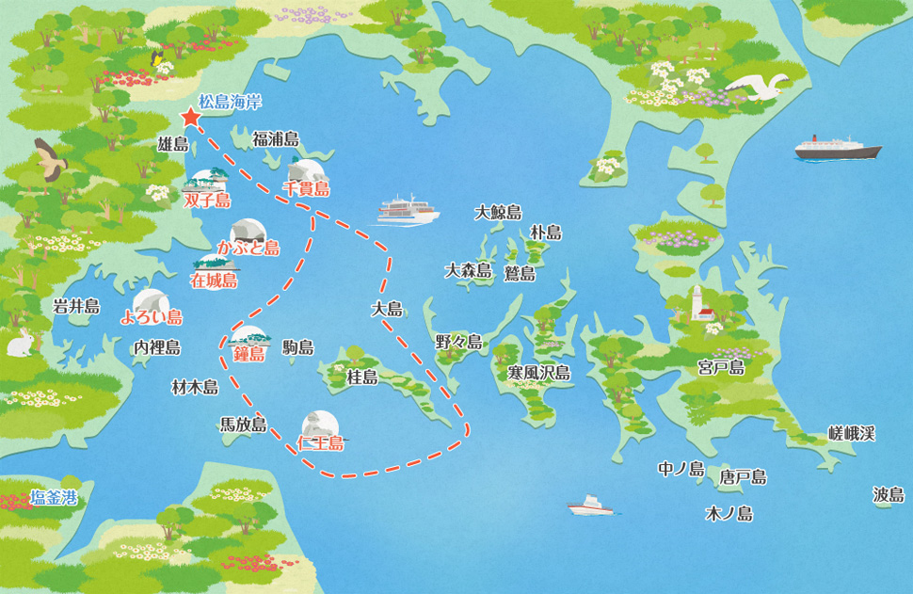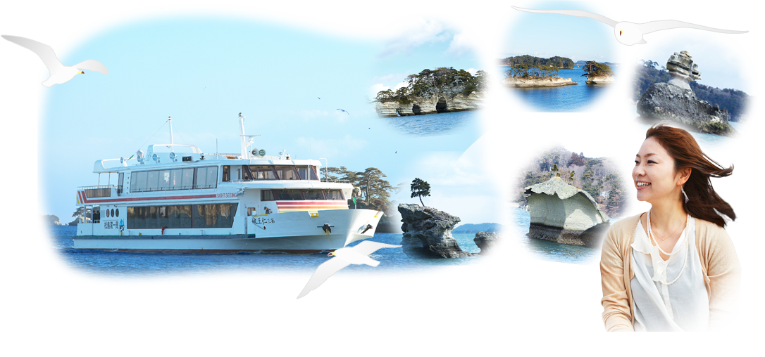

Matsushima bay is one of the best 3 views of Japan.

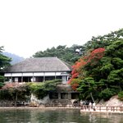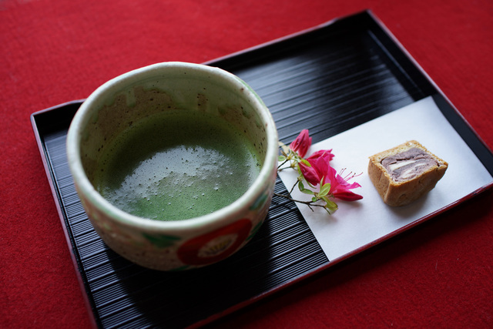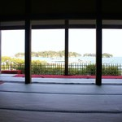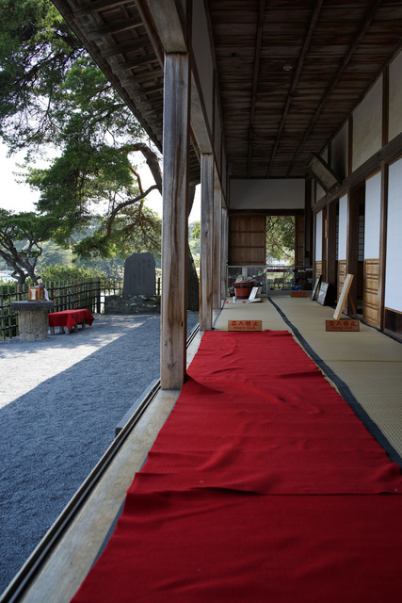

**Matsushima Kanrantei (Built in 16th century)**

**食べログhttp://tabelog.com/miyagi/A0404/A040404/4001724/**

Matsushima view and traditional green tea with Japanese-style confection

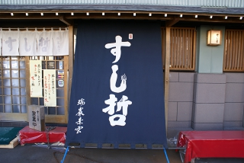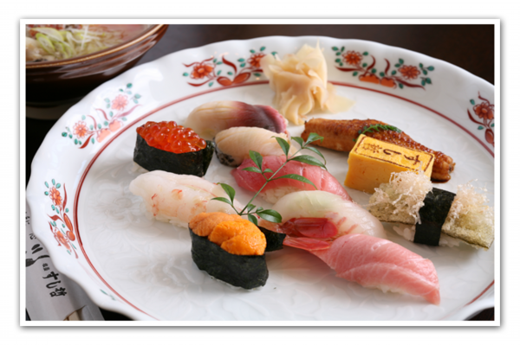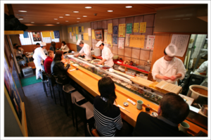

**Dinner: Sushi restaurant (Sushi Tetsu)**

**すし哲ホームページhttp://www.shiogama-sushitetsu.com/shiogama/index.html**

You can enjoy delicious Sushi dinner.

**Schedule:**

13:00-13:30 move to JR Aoba-Dori station by walk

13:50-14:30 move to JR Matsushima-Kaigan station by train

15:00-16:00 Matsushima Bay Cruising (Boat)

16:00-16:30 Matsushima-Kanrantei

17:12-17:21 move to JR Hon-Shiogama station

17:30-19:30 Dinner: Sushi Restaurant (Sushi Tetsu in Shiogama)

20:09-20:39 move to JR Aoba-Dori station

*Please let me know if you have food allergies.

Information

June 11 (Thu)

14:35 Arrival at Sendai Airport

After arriving at the airport, please move to the JR Sendai Station by train. The train fee is 650JPY.

Students will guide you to the accommodation (Hotels/Tohoku University Katahira Guest House).

Tohoku University Katahira Guest House is a 10-minute walk away from the Workshop venue and a downtown area of Sendai. The details of accommodation for Tohoku University Katahira Guest House are as follows.

Room rate: 2,520JPY per a night (single room)

Check-in date: June 11 (Thu.)

Check-out date: June 14 (Sun.)

LAN (cable) is available in each room.

Please contact Ms. Akama (akama@plasma.ifs.tohoku.ac.jp) to book the house.

*Students are not available.

Hotels: The price is generally from 4,000JPY to 10,000JPY for a single room per night. Please contact to Ms. Akama (akama@plasma.ifs.tohoku.ac.jp), if you need help to book hotels.

**Plasma and pulsed power applications for agriculture(14 pt, bold)**

Abstract template (Please remove this box when you send an abstract.)

Koichi Takaki, …(Authors, 12 pt, Underline a speaker)

*Iwate University, 4-3-5 Ueda, Morioka, Iwate 020-8551, Japan (Affiliation, 11pt Italic)*

e-mail : takaki@iwate-u.ac.jp (email, contact person only, 11pt)

All abstracts must be submitted in English (Times New Roman, 12pt) and the maximum length including figures is A4 one page. The abstract book will be printed in black and white.

Plasma and pulsed power applications for agriculture and fishery are described. Repetitively operated compact pulsed power generators with a moderate peak power were developed for the applications in several stages of agriculture and fishery. Types of pulsed power that have biological effects are caused with gas discharges, water discharges, and electromagnetic fields. The discharges yield free radicals, UV radiation, intense electric field, and shock waves. Biologically based applications of pulsed power are performed by selecting the type that gives the target objects the adequate result from among these agents. For instance, intense electric fields form pores on the cell membrane, which is called electroporation [1], or influence the nuclei. The radicals in water react with cell membrane of bacteria. These applications are mainly based on biological effects and can be categorized as germination of plant seeds; control of growth rate of the vegetables and fruits such as *Fragaria × ananassa*, *Spainacia oleracea* and *Raphanus sativus var. sativus* [2]; improvement of yielding rate of mushroom [3-5]; keeping freshness for a relatively longer period of perishables such as fish and shellfish [6]; decontamination of air and liquid to inhibit degradation of agricultural products [7]. These applications can contribute a food supply chain in Japan and the world.

[1] A. Nakagawa *et al*., IEEJ Trans. FM, **133** (2013) 32. [in Japanese]

[2] K. Takaki *et al*., J. Phys. Conf. Series, **418** (2013) 012140.

[3] K. Takaki *et al*., Acta Physica Polonica A, **115** (2009) 1062.

[4] K. Takaki *et al*., J. Plasma Fusion Res. **8** (2009) 556.

[5] K. Takaki *et al*., Microorganisms, **2** (2014) 58.

[6] T. Ito *et al*., J. Adv. Oxid. Technol. **17** (2004) 249.

[7] S. Koide *et al*., J. Electrostatics, **71** (2013) 734.

2nd Japan-Taiwan Workshop on Plasma Life Science and Technology (JTPL 2015)

June 11-13, 2015, Sendai, Japan

Registration Form

(Please fill in this form and send it back by May 11 to <[akama@plasma.ifs.tohoku.ac.jp](mailto:skana@oita-u.ac.jp)>)

|  |  |  |
| --- | --- | --- |
| 1. Participant and Author Information | | |
| [ ] Invited/General Participant [ ] Student | | |
| [ ] Invited [ ] Poster [ ] Listen-only [ ] Other | | |
| Last (Family) Name: | | First (Given) Name: |
| Title: [ ]Prof. [ ]Dr. [ ]Mr. [ ]Ms. | | |
| Affiliation (University/Company): | | |
| Address: | | |
| Nationality: | | |
| E-mail: | | |
| Phone: | Fax: | |
| 1. Registration, Banquet and Excursion   (Please make a payment in cash at the conference venue.) | | |
| [ ] Registration (Invited and General Participants) 10,000JPY = yen  [ ] Registration (on site for invited/general) 15,000JPY = yen  [ ] Registration (Students, free)  [ ] Banquet (Please check if you join) 5,000JPY = yen  [ ] Excursion (Please check if you join. Dinner is included. The fee is 5000JPY for all participants ) 5,000 JPY = yen  Total = yen | | |
| 1. Question to faculties | | |
| If your students will attend, please write the number of students. [ ] persons | | |
| 1. Accompanying Persons Information | | |
| Last (Family) Name: | | First (Given) Name: |
| Title: [ ]Dr. [ ]Mr. [ ]Ms. | | |
| Nationality: | | |
| Note if any information : | | |
| 1. Requests | | |
| [ ] I would like to stay at Tohoku University Katahira Guest House.  (faculty only, \2,520/night)  [ ] I am a vegetarian. [ ] I have a food allergy. (Food: )  [ ] Other requests:  [ ] | | |