The Title: First Letter of Each Word must be Capitalized, Maximum Two Lines, Times 14pt, Bold Single Space
(leave one blank line, two if the title contains only one line)
Authors names: Shigenao Maruyama, etc.: Times 11pt, centered, Underline the Presenting Author’s name.
Affiliation and address: Times 11pt, centered, Maximum four lines.
E-mail of corresponding author: Times 11pt, centered.

Introduction
This is a Word format (A4 page) to prepare your manuscript. The instructions below must be respected by all authors. An abstract for poster presentation should be 1 page. The abstract should clearly state the purpose, the methodology, the results and the conclusions of the work.

Methodology
Following the abstract, it is composed of one column. The left and right margins must be 2 cm, the top and the bottom margins must be 2.5 cm.
The manuscript is to be typed using "Times" (or equivalent). The size for the title is 12pt. All the other parts of the text are typed using Times 11pt. The title is centered and boldface. The spacing between the lines is one (single spacing).
The title must be centered between the margins. Leave one blank line between the centered title and the centered name(s) of the author(s). Underline the Presenting Author’s name. Follow immediately below, and on a separate line, with his or her (their), affiliation(s). Leave two blank lines before starting the text.
The figures are reduced to fit within the margin. Symbols and legends are large enough to be readable.

Results
Once after you have completed your manuscript in Word format, you must create a PDF file. The PDF file you prepare should be submitted from Web Page
http://www.ifs.tohoku.ac.jp/gcoe/NanoRad2012/poster_submission/index.html
If you prefer TeX, you can prepare the manuscript by using TeX. In this case, however, the manuscript should be made in the same format as Word one. Please submit PDF file only in this case.
Manuscripts will be printed in black and white for publication.

Concluding remarks
Due date of the one-page abstract submission is March 31, 2012

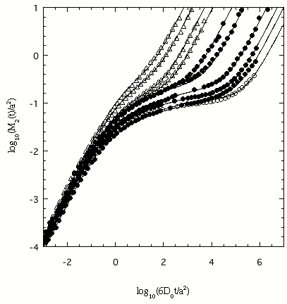

Fig. 1 A log-log plot of the mean-square
displacement vs time. Etc.

