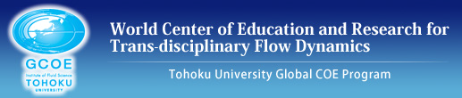
Tohoku University Global COE Program:
World Center of Education and Research for Trans-disciplinary Flow Dynamics

2010 Application Form
GCOE Special Research Student at the Institute for
International Advanced Research and Education, Tohoku University
①Applicant
Name:
Affiliation: Masters Program in the year, Faculty & Course:
Entrance (mm/yy):
Phone: Email:
② Supervisor
Name:
University/Institute: Position:
③ Describe your motivation for applying to be a Special Research Student at the Institute for International Advanced Research and Education, Tohoku University, in particular, your motivation for devoting yourself to the challenge of research in advanced and trans-disciplinary fields.
④Describe your research plan(s) clearly. Specify the objectives and contents of the research plans, and how deeply you intend to research this theme in the three year period before you acquire your PhD.
⑤ Describe the points of originality in your research in the trans-disciplinary field as well as the appealing points of your research program.
Affiliation and Name of Applicant:
Date: / / (dd/mm/yy)
⑥Describe about the academic significance and the value of your research theme, and describe also the logics how your theme has been generated.
⑦ Clearly describe your study plan and the required/desirable academic research environment for you to complete your doctoral dissertation.
Affiliation and Name of Applicant:
Date: / / (dd/mm/yy)
⑧ Academic achievements
Please list your academic achievements in the following five categories:
- Presentations at national conferences in Japan.
- Presentations at international conferences in Japan or abroad in non-Japanese language.
- Refereed proceedings and papers.
- Other papers accepted by academic journals.
- Any awards received.
Affiliation and Name of Applicant:
Date: / / (dd/mm/yy)

