The title must be Maximum Two Lines, Times 12pt, Bold Single Space:
International Conference on Flow Dynamics
(leave one blank line, two if the title contains only one line)
Authors names: M. Tokuyama, etc.: Times 10pt, centered, Underline the Presenting Author’s name.
Affiliation and address: Times 10pt, centered, Maximum four lines.

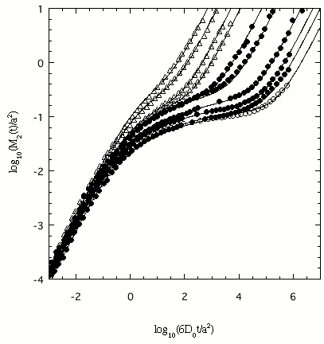
Fig. 1 A log-log plot of the mean-square
displacement vs time. Etc.

This is a Word format to prepare your abstract.
The instructions below must be respected by all authors. All authors are allowed TWO PAGES, which may include references and figures. It is composed of two columns. Each column must be 8 cm width. The spacing between the columns must be 1 cm. The left and right margins must be 2 cm, the top and the bottom margins must be 2.5 cm.
The manuscript is to be typed using "Times" (or equivalent). The size for the title is 12pt. All the other parts of the text are typed using Times 10pt. The title is centered and boldface. The spacing between the lines is one (single spacing). The title must be centered between the margins. Leave one blank line between the centered title and the centered name(s) of the author(s). Underline the Presenting Author’s name. Follow immediately below, and on a separate line, with his or her (their), affiliation(s). Leave two blank lines before starting the text.
The equations are numbered and typed in the appropriate place in the text. The size of the character is similar to that used for the text (Times 10pt). The following equation is an example created by Word Equation Editor.
$\frac{d\text{df}(r,t)}{\text{dt}}{\text{=Ñ}}^{2}\left[\text{Ds}(\text{df}(r,t))\text{df}(r,t)\right]+x(r,t)\text{.}$ (
The figures are reduced to fit within the margins of each column. Symbols and legends are large enough to be readable. Tables and figures are numbered in the order they appear in the text.

Table 1. Fitting results for x, y, and z

x | y | z
0.1 | 15 | -1.0
0.2 | 18 | -0.1
0.3 | 20 | -0.01

The list of references must place at the end of the text if needed. The references must be numbered in order of text citation and abbreviated in an appropriate form, using the names of all authors preceded by initials.
A manuscript that does not confirm to these instructions will be returned to the author.
The abstract must be sent to
icfd2006@21coe.ifs.tohoku.ac.jp
no later than October 2, 2006 as an e-mail attachment. The e-mail should include the following information.
Subject: Abstract for ICFD2006
- OS number (OS 1 to OS 7)
- Authors' names (affiliations)
- Title of the presentation
- Contact person's name, regular mail address, e-mail address, and fax number
Notification of acceptance will be sent to the author by an e-mail by October 13, 2006.
References
[1] M. Tokuyama, Phys. Rev. E, 54 (1996), R106.
[2]

