The Title: First Letter of Each Word must be Capitalized, Maximum Two Lines, Times 12pt,
Bold Single Space
(leave one blank line, two if the title contains only one line)
Authors names: Shigenao Maruyama, etc.: Times 10pt, centered, Underline the Presenting Author’s name.
Affiliation and address: Times 10pt, centered, Maximum four lines.
E-mail of corresponding author: Times 10pt, centered.

ABSTRACT
Abstract should be typed in Times 9 pt.
(within five lines)

(one line spacing between Abstract and Main text)

1. Introduction
This is a Word format (A4 pages) to prepare your manuscript. The instructions below must be respected by all authors. A paper should be 2 pages, which include the following structure:

Title (see above format)
Name (s) of author (s) and affiliation (s)
E-mail of corresponding author
Abstract
Main text including table (s) and figure (s)
Conclusions
Acknowledgements (if applicable)
References
Appendices (if applicable)

2. Method
Following the abstract, it is composed of two columns. Each column must be 8 cm width. The spacing between the columns must be 1 cm. The left and right margins must be 2 cm, the top and the bottom margins must be 2.5 cm.
The manuscript is to be typed using "Times" (or equivalent). The size for the title is 12pt. All the other parts of the text are typed using Times 10pt. The title is centered and boldface. The spacing between the lines is one (single spacing). The title must be centered between the margins. Leave one blank line between the centered title and the centered name(s) of the author(s). Underline the Presenting Author’s name. Follow immediately below, and on a separate line, with his or her (their), affiliation(s). Leave one blank lines before starting the text.
The equations are numbered and typed in the appropriate place in the text. The size of the character is similar to that used for the text (Times 10pt). The following equation is an example created by Word Equation Editor.
$\frac{d\text{df}(r,t)}{\text{dt}}{\text{=Ñ}}^{2}\left[\text{Ds}(\text{df}(r,t))\text{df}(r,t)\right]+x(r,t)\text{.}$ (
The figures are reduced to fit within the margins of each column. Symbols and legends are large enough to be readable. Tables and figures are numbered in the order they appear in the text.

Table 1. Fitting results for x, y and z

x | y | z
0.1 | 15 | -1.0
0.2 | 18 | -0.1
0.3 | 20 | -0.01

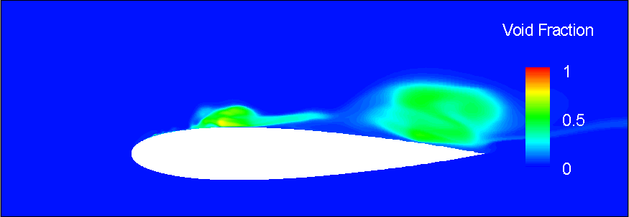
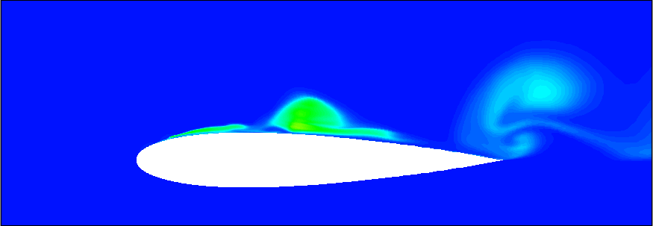
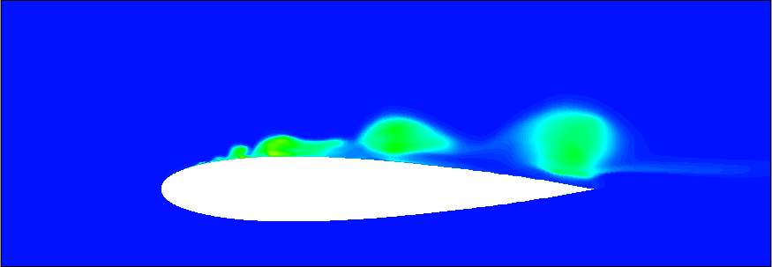

Fig. 1 Time evolution of aspect of cavitation

The list of references must be placed at the end of the text if needed. The references must be numbered in order of text citation and abbreviated in an appropriate form, using the names of all authors preceded by initials.
A manuscript that does not confirm to these instructions will be returned to the author.

3. Results and Discussion
Once after you have completed your manuscript in Word format, you must create a PDF file. Both Word file and PDF file you prepare should be submitted from ICFD Web Page.
If you prefer TeX, you can prepare the manuscript by using TeX. In this case, however, the manuscript should be made in the same format as Word one. Please submit PDF file only in this case.
Proceedings will be distributed to the conference participants with USB memory sticks. Color figures are acceptable.

4. Concluding remarks
Due date of the paper submission is September 1, 2013.

References
[1] M. Tokuyama, Phys. Rev. E, 54 (1996), R106.
[2]

