Title (16 pt. Times New Roman Boldface, Upper- and Lower-Case, and Centered over Two Columns)

Author 1*, Author 2** and Author 3*

* Affiliation 1, Address, Zip code, Country.
** Affiliation 2, Address, Zip code, Country.
E-mail: <corresponding e-mail address>

Abstract

Your paper should be in the same format as this file. The abstract goes here. This is required for invited lectures and special session (no abstract for poster session). Your abstract should be 150 – 200 words here clearly outlining the contribution of your paper.

1. Introduction
Clearly explain the nature of the problem, previous work, purpose, and contribution of the paper.

2. Headings
Title should be 16 pt. Times New Roman Boldface, and upper- and lower-case. Authors’ name should be 12 pt. Times New Roman, and upper- and lower-case. Leave one blank line between them. Affiliation and address of the authors, and e-mail address of the corresponding author should be 10 pt. Times New Roman. Leave one blank line between the authors’ name and them. They should be centered spanning the entire page.
Leave two blank lines between the headings and body of the text.

3. Body of Text
The length of the manuscript MUST be 6, 8 or 10 pages for invited lectures, 2 or 4 pages for special session, and 2 pages for poster session. For the body of your document, use 10 pt. Times New Roman font, single-spaced. It should be in two columns. Each column is 80 mm in width and fully justified (not only left-justified).

3.1 Paper Size: A4 (210 mm by 297 mm, 8.26” by 11.69”). LETTER (8.5” by 11.0” or 21.6 cm by 27.9 cm) will NOT be accepted. Leave 25 mm margins at the top, and 20 mm at the bottom and on the left and right sides.

3.2 Text Headings: The primary text headings should be numbered, 10 pt. Times New Roman boldface, upper- and lower-case, and centered. The body text must start on the next line (no extra space from the heading to the text).
3.2.1 Subheadings: The secondary headings should be numbered, 10 pt. Times New Roman boldface, upper- and lower-case, and flush left with the left margin, followed by a colon, a space and its text.
The third headings follow the second heading style, with the exception that it must be indented from the left margin. The heading must start on the next line of the former paragraph (no extra space from the last line of the former paragraph to the heading).

3.3 Equations: If you need to insert an equation, start a new line and indent as the first line of the paragraphs.
$\frac{∂u}{∂t}+u\frac{∂u}{∂x}=−\frac{∂p}{∂x}+\frac{1}{\text{Re}}\frac{∂^{2}u}{∂x^{2}}$ (1)
It is not necessary to indent the line following an equation.

4. Figures and Tables
All figures – photographs, graphs, and/or line drawings – and tables should be numbered consecutively and captioned. All callouts within figures and tables should be no smaller than 7 pt. All figures should be in grayscale, or black and white. The title or description of the figure or table should be 9 pt. Times New Roman, sentence case (first letter capitalized), and centered.

5. Conclusion
Clearly indicate advantages, limitations, and possible applications.

Acknowledgements
A brief acknowledgement section may be included between the Conclusion and References (optional). Do NOT include author biographies.

References
References need to be numbered as they appear in your text ([1], [2], [3], etc) and should appear in your reference section in numerical order (not alphabetically).
The required format for references is as follows:

(Format for Proceedings Papers)
[1] Shirai, A., Fujita, R., and Hayase, T., Flow simulation of neutrophils in capillary network (Effect of capillary geometry on transit time of cells through network), Proc. IASTED Int. Conf. Biomed. Eng. (BioMED-2005), (2005), 284-289.
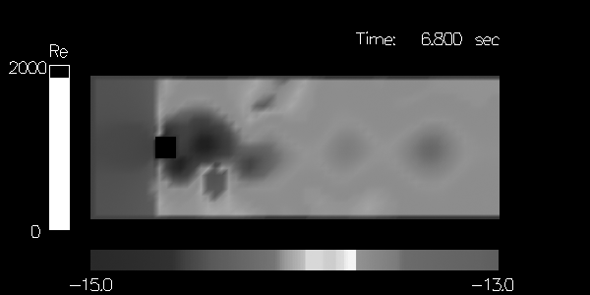
Fig. 1 Visualization result with adaptive colormaps.
Note that the proceedings title is set in italics. Title of the paper is optional.

(Format for Journal Papers)
[2] Hogg, J.C., McLean, T., Martin, B.A., and Wiggs, B., Erythrocyte transit and neutrophil concentration in dog lung, J. Appl. Physiol., Vol. 65 (1988), 1217-11225.
Note that the journal title is set in italics. Title of the paper is optional.

(Format for Books)
[3] Fung, Y.C., Biomechanics: Circulation, 2nd Ed., (1997), Springer-Verlag, New York.
.Note that the title of the book is in upper and lower case letters and italicized. Place of publication and publisher are given.

Deadlines
The deadline on the abstract submission is April 30, 2006. You can submit your manuscript electronically. Please visit the website for the detailed information of the symposium.

Color Plates
Editors invite fine color figures for the color plate (collection of color figures) other than the abstract, up to 2 figures for keynote lectures, and 1 for special session and poster session. Recommended format is as follows:
GIF, JPEG, PostScript, TIFF, or WMF

