The title must be Maximum Two Lines, Times 12pt, Bold Single Space:
the 3rd International Workshop on Complex Systems
(leave one blank line, two if the title contains only one line)
Authors names: M. Tokuyama, etc.: Times 10pt, centered, Underline the Presenting Author’s name.
Affiliation and address: Times 10pt, centered, Maximum four lines.

This is a Word format to prepare your abstract. If you are not familiar with Tex, then please use it. Otherwise, we strongly ask you to submit it in Tex file.
The instructions below must be respected by all authors, submitting a manuscript for invited talks, oral presentations, or poster presentations. All authors are allowed ONE PAGE, which may include references and figures. It is composed of two columns. Each column must be 8 cm width. The spacing between the columns must be 1 cm. The left and right margins must be 2 cm, the top and the bottom margins must be 2.5 cm.
The manuscript is to be typed using "Times" (or equivalent). The size for the title is 12pt. All the other parts of the text are typed using Times 10pt. The title is centered and boldface. The spacing between the lines is one (single spacing). The title must be centered between the margins. Leave one blank line between the centered title and the centered name(s) of the author(s). Underline the Presenting Author’s name. Follow immediately below, and on a separate line, with his or her (their), affiliation(s). Leave two blank lines before starting the text.
The equations are numbered and typed in the appropriate place in the text. The size of the character is similar to that used for the text (Times 10pt). The following equation is an example created by Word Equation Editor.
$\frac{d\text{df}(r,t)}{\text{dt}}{\text{=Ñ}}^{2}\left[\text{Ds}(\text{df}(r,t))\text{df}(r,t)\right]+x(r,t)\text{.}$ (
The figures are reduced to fit within the margins of each column. Symbols and legends are large enough to be readable. Tables and figures are numbered in the order they appear in the text.

Table 1. Fitting results for x, y, and z

X | y | z
0.1 | 15 | -1.0
0.2 | 18 | -0.1
0.3 | 20 | -0.01

The list of references must place at the end of the text if needed. The references must be numbered in order of text citation and abbreviated in the form used in PRE, using the names of all authors preceded by initials.
A manuscript that does not confirm to these instructions will be returned to the author. If an acceptable version is not available when the abstracts go to the printer, the paper will be withdrawn from the program.
This file must be sent electronically to
iwcs2005@athena22.ifs.tohoku.ac.jp
by July 31, 2005 (Japan local time) for oral presentation
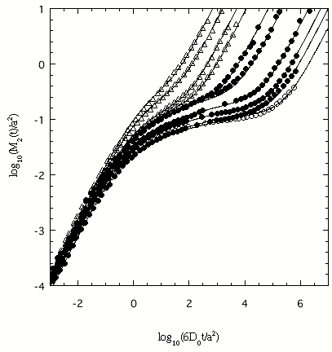
Fig. 1 A log-log plot of the mean-square
displacement vs time.Etc., …….

and August 31, 2005 (Japan local time) for poster presentation.
Most of contributed papers will be presented at the poster sessions, because of the limitations in time at the workshop. Notice of accepted contribution will be informed the author by an email before middle of August, 2005.

References
[1] M. Tokuyama, Phys. Rev. E 54 (1996) R106.
[2]

