Type the Title of your Paper Here in 12 pt

Shigenao Maruyama¹, Co-Author name¹, Co-Author name² (Underline for the presenting author.)
¹Affiliation
Street, City, State, Zip-code, Country
²Affiliation
Street, City, State, Zip-code, Country

ABSTRACT
Abstract should be typed within five lines. All papers published in the proceedings of ICFD2014 must be formatted in accordance with these instructions. This document is a MS-Word template which defines the required format. MS-Word of this document is available on the conference website:

(Leave one blank line between the abstract and the main text)

1. Introduction
This is a MS-Word format (A4 pages) to prepare your manuscript. The instructions below must be followed by all authors. The length of a paper should be two pages. It should include:

Title (see above format)
Name (s) of author (s) and affiliation (s)
Abstract
Main text including table (s) and figure (s)
E-mail of corresponding author
Conclusions
Acknowledgements (if applicable)
References
Appendices (if applicable)

2. Method
Following the abstract, it is composed of two columns. Each column must be 8 cm width and justified. The spacing between the columns must be 1 cm. The left and right margins must be 2 cm, the top and the bottom margins must be 2.5 cm.
The manuscript is to be typed using "Times New Roman" (or equivalent). The size for the title is 12 pt. All the other parts of the text are typed using 10 pt. The title is centered and boldface. The spacing between the lines is one (single spacing). The title must be centered between the margins. Leave one blank line between the centered title and the centered name(s) of the author(s). Underline the Presenting Author. Follow immediately below, and on a separate line, with his or her (their), affiliation(s). Leave one blank line before starting the text.
The equations are numbered and typed in the appropriate place in the text. Equation number should be flush right. The size of the character is similar to that used for the text (Times 10 pt). The following equation is an example created by Word Equation Editor.
(
The figures are reduced to fit within the margins of each column. Symbols and legends are large enough to

Corresponding author: Shigenao Maruyama
E-mail address: icfd2014@fmail.ifs.tohoku.ac.jp
be readable. Tables and figures are numbered in the order they appear in the text.

Table 1. Table captions go above the table, captions that are 2 or more lines should be flushed left (one line table captions should be centered), 1 line space above and below the caption.

x | y | z
0.1 | 15 | -1.0
0.2 | 18 | -0.1
0.3 | 20 | -0.01

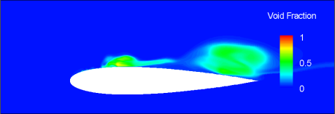
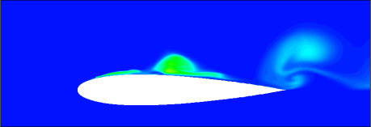
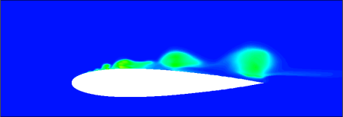

Fig. 1 Two or more lines captions should be flushed left under the figure. Add 1 line space above the figure caption (One line figure captions should be centered under the figure).

The list of references must be placed at the end of the text. The references must be numbered in order of text citation and abbreviated in an appropriate form [1,2], using the names of all authors preceded by initials.
A manuscript that does not confirm to these instructions will be returned to the author.

3. Results and Discussion
Once after you have completed your manuscript in Word format, you must create a PDF file. Both Word file and PDF file you prepare should be submitted from ICFD Web Page.
If you prefer TeX, you can prepare the manuscript by using TeX. In this case, however, the manuscript should be made in the same format as MS-Word one. Please submit PDF file only in this case.
Proceedings will be distributed to the conference participants with USB memory sticks. Color figures are acceptable.

4. Concluding Remarks
Due date of the paper submission is July 16, 2014.
References
[1] S. Maruyama, T. Yabuki, T. Sato, K. Tsubaki, A. Komiya, M. Watanabe, H. Kawamura, K. Tsukamoto, Deep-Sea Research Part 1, 58 (2011) 567－574.
[2] R.S. Loss, S.B. Williams, Proc. 9th Asia-Pacific Conf. Combust., (2013), 809.

