Experimental and Numerical Studies of Shock Wave Attenuation
over Bodies with Complex Configurations
Atsushi Abe

Clarifications of shock wave interaction with complex media such as human tissues and of blast wave interaction with real ground surface at volcanic eruptions and large-scale explosions are very important topic not only for shock wave dynamics but also modern industrial applications. In this thesis, processes of shock wave attenuation over three-dimensional bodies with complex configurations were analyzed by using experimental and numerical methods.
In chapter 2, experimental methods were described. 60mm x 150mm diaphragmless shock tube with high repeatability of shock wave generation and a double exposure holographic interferometry with high spatial resolution were used. By using these methods, a animated display of sequential holographic interferograms was created.
In chapter 3, a numerical method for solving the two-dimensional unsteady Navier-Stokes equation is presented, in which the so-called Weight Averaged Flux (WAF) scheme and an unstructured adaptive mesh system are used. In order to validate the proposed scheme numerical results are compared with interferometric results. The parallel computation is conducted with MPI.
In chapter 4, the attenuation of shock wave over arrayed cylinders and spheres with various arrangements and diameters was investigated numerically and experimentally. In comparisons between the arrangement and diameter of arrayed cylinders, it was found that the difference not only of the porosity but also of the arrangement had a significant influence on the shock wave attenuation. Comparing 3-D arrayed spheres with 2-D arrayed cylinders, for arrayed spheres shock wave was attenuated more effectively than for arrayed cylinders due to 3-D expansion waves generated by three-dimensional interactions of transmitted shock waves with arrayed spheres.
In chapter 5, shock wave attenuation over ground surfaces with various irregularities was examined experimentally. These models were: an three-dimensional artificial grass; solid two-dimensional fences; solid three-dimensional arrayed sharp cones and cylinders; flexible three-dimensional arrayed thimbles. It was found that the movable boundary models attenuate transmitted shock wave more effectively due to the fact that the movement of flexible models absorbs momentum and energy of the flows more effectively than the other models.
In chapter 6, shock wave attenuation over solid and rigid porous baffle plates was investigated numerically and experimentally. Attenuations of both transmitted shock wave and reflected shock waves generated by the rigid porous baffle plates were observed by interferometric observations. The transmitted shock wave was suppressed more successful for the rigid porous case than for the solid case. The shock wave speed became slower although its strength became larger than that of the incident shock wave.

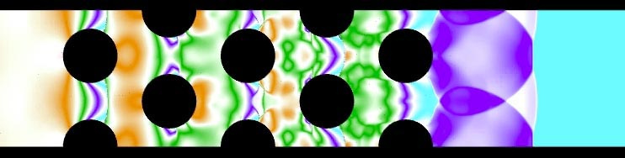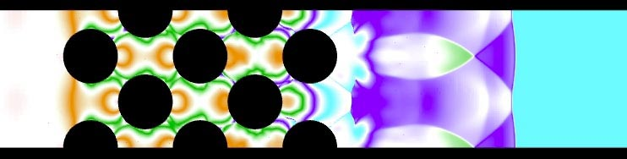
30mm dia., Interval 43.3mm 30mm dia., 30.0mm interval
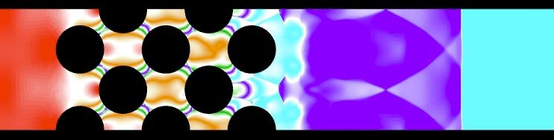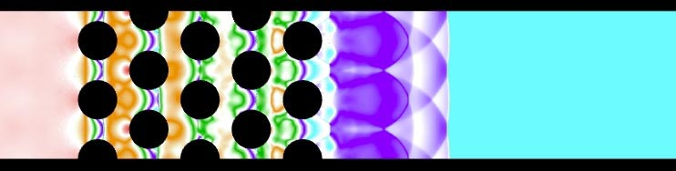
30mm dia., Interval 26.6mm 20mm dia., 26.0mm interval
Numerical results of shock wave propagation over arrayed cylinders (pressure distribution)

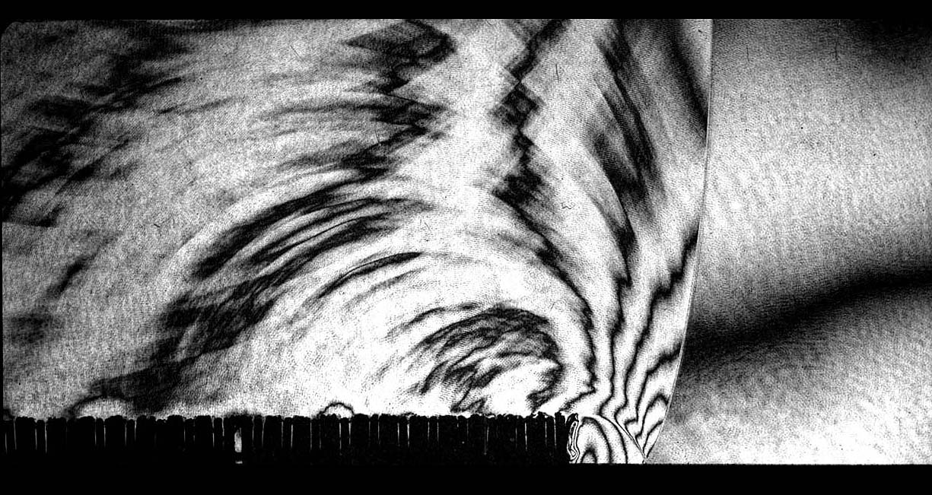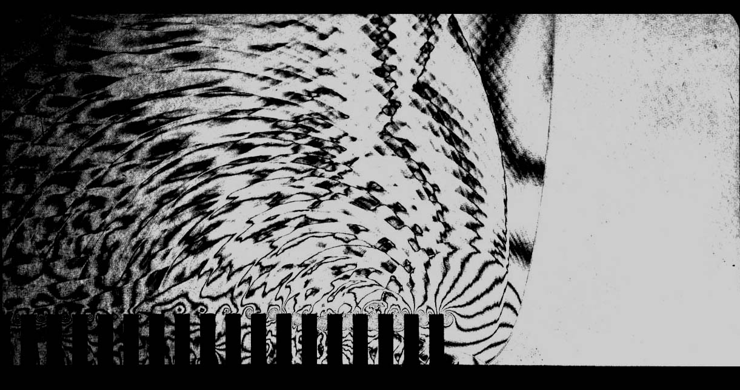
Grassland (Flexible) 2-D fences (Solid)
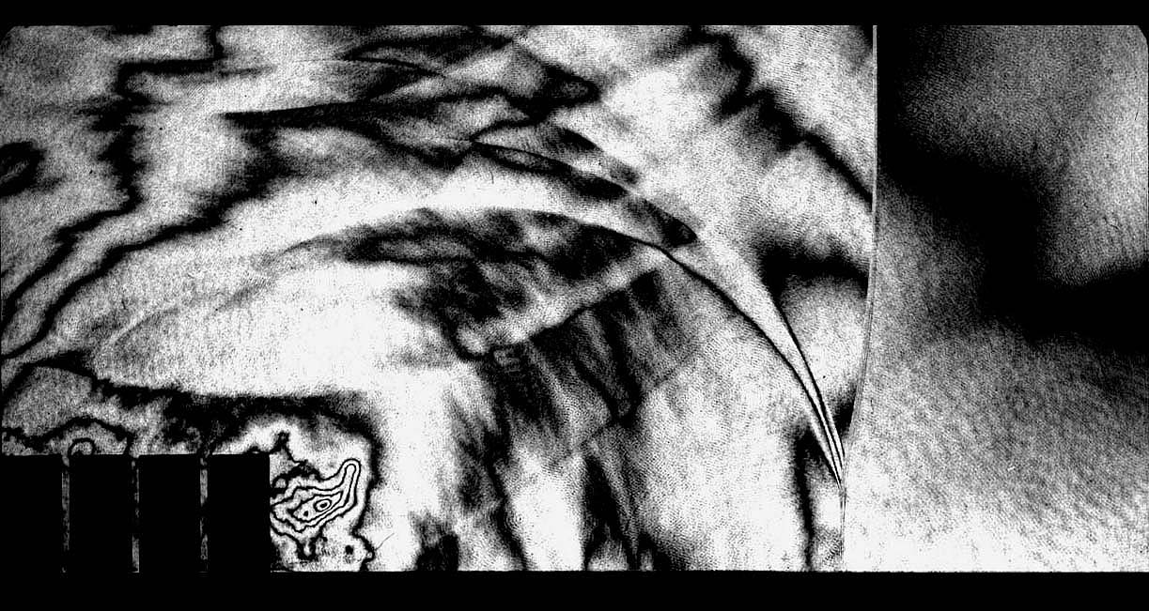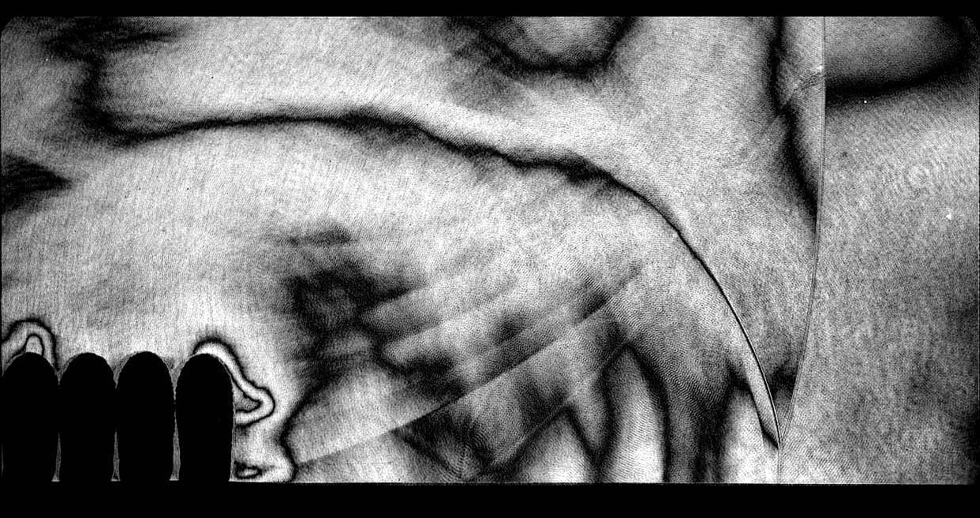
3-D arrayed cylinders (Solid) 3-D arrayed rubber thimbles (Flexible)
Experimental results of shock wave propagation over complex ground surfaces

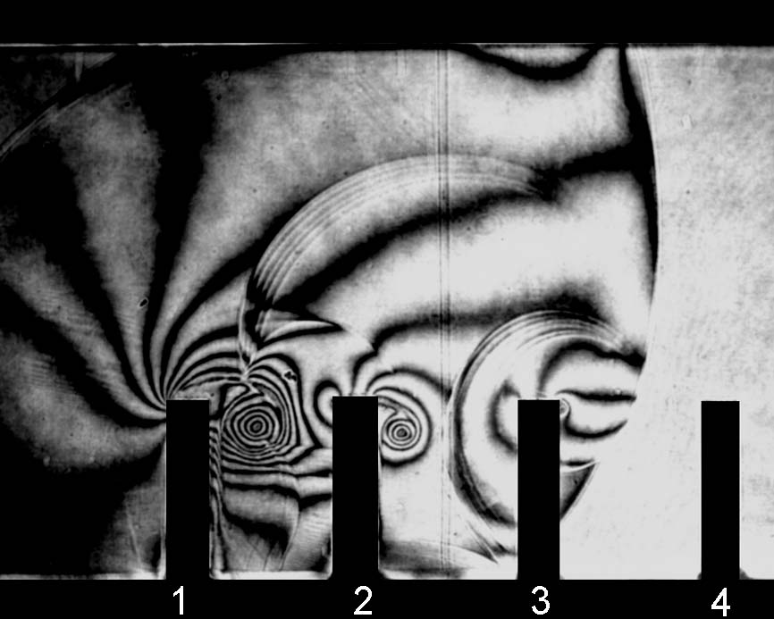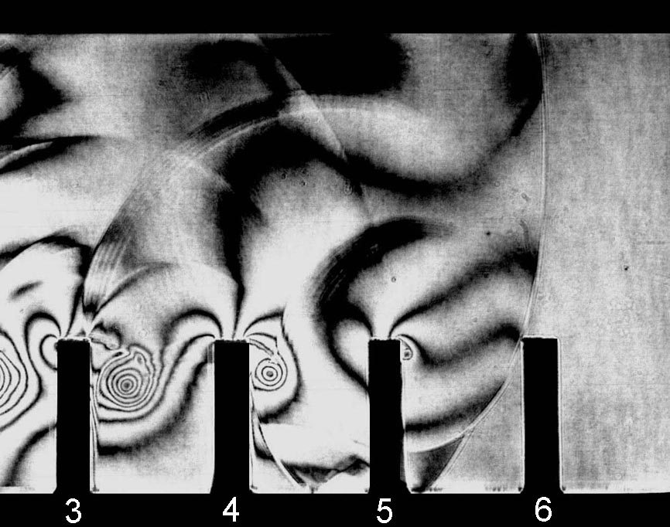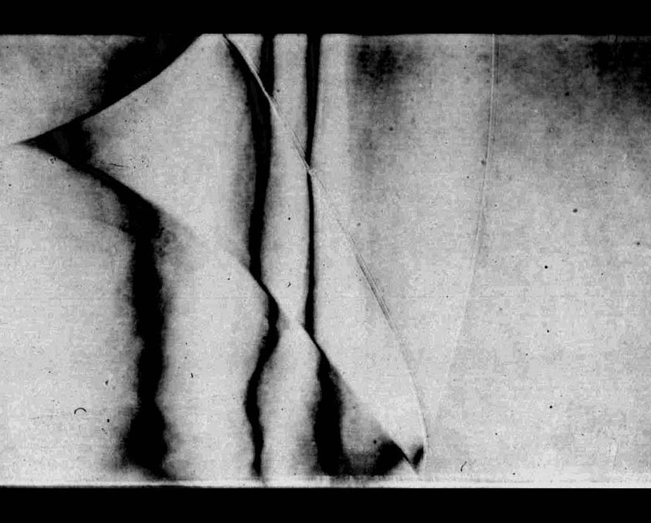
Rigid porous baffle plates
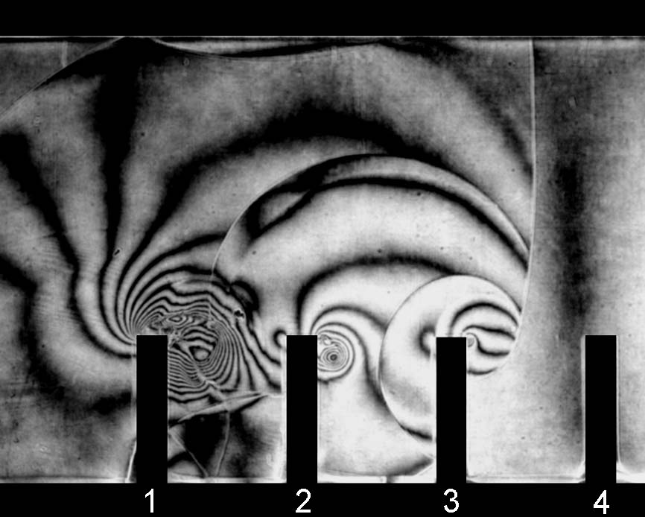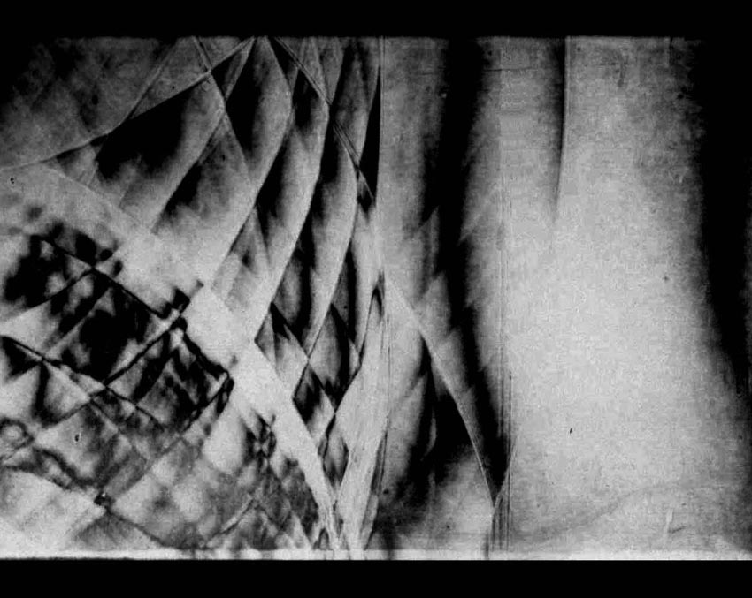
Solid baffle plates
Comparison of experimental results of shock wave interaction with baffle plates

