An experimental study of characterization and development of space debris bumper shields

Ichiro Kato

The number of space debris tends to increase year by year so that their impingement would create non-negligible hazard to all the spacecrafts, including the International Space Station (ISS), satellites and space shuttle. The average impact velocity of space debris is in low earth orbit is 10 km/s and their distribution is increasing in impact velocity approximately 5 km/s and 10 km/s. At these speed range, even small debris under 10 mm in dia. has an enormous impact energy. To protect spacecrafts from debris impacts, so-called Whipple Bumper Shield, which consists of a thin metal plate spaced at a stand-off distance from main wall, is mainly applied. Most impacts are oblique due to difference inclination and right ascension of ascending node.
The damage of main wall depends on the process of formation of debris cloud and distribution of fragments. Therefore, the visualization would be one of the most straight way for their measurement. Traditionally debris cloud is used to be visualized by means of either direct shadowgraph or high speed cinematography. However, the spatial distribution of shattering fragments is three-dimensional so that such two-dimensional visualization is not adequate to apply. For this purpose, hypervelocity impact (HVI) tests of UHMW-PE projectiles on thin Al alloy bumpers have been conducted by using two-stage light gas gun and we have applied holographic observation to normal and oblique impacts by using a pulse ruby laser. Fig.1,2 show 3-D hologram of debris cloud at normal and oblique impacts. These results revealed that the shape of debris cloud and their internal structures are significantly different between normal and oblique impacts.
Impact flash is one of the most important HVI phenomena. So, impact flash emitted during impacts of projectiles on thin bumpers has measured by spectroscopic system in two-stage light gas gun. Temperatures of CN have been estimated by comparing numerical spectra obtained by SPRADIAN with measured spectra. Table 1 shows results of estimated temperature of CN. Little difference in estimated temperatures of CN was found between normal and oblique impacts.
HVI with UHMW-PE projectiles against an Al alloy bumper shield was numerically simulated by SPH method using AUTODYN 3-D. Fig. 3, 4 show numerical results of debris cloud. SPH method was found to be useful for the qualitative simulation of HVI by comparing numerical simulation with results of visualization.

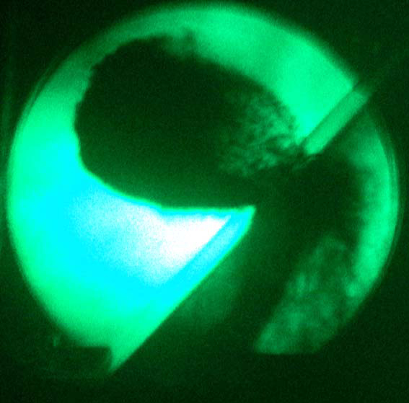
Fig. 2 Debris cloud (Oblique impact)

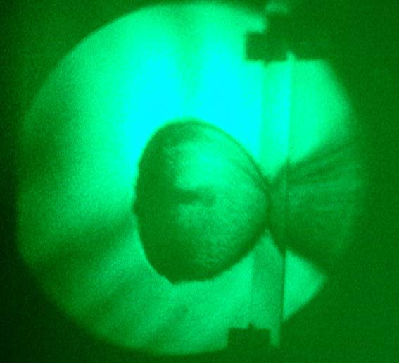
Fig. 1 Debris cloud (Normal impact)

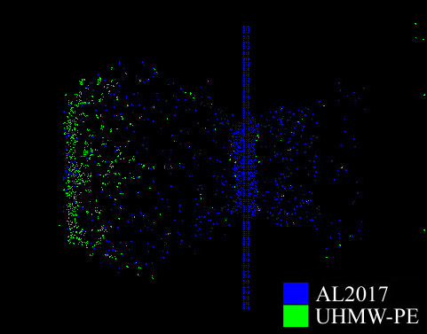
Fig. 3 Numerical simulation (Normal impact)
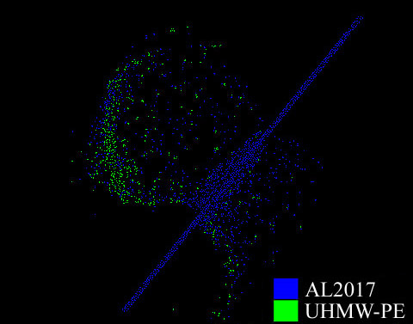
Fig. 4 Numerical simulation (Oblique impact)
表1 CN violetバンドの推定温度
Impact type | Test Pressure : N₂  [Pa] | Impact velocity  [km/s] | Estimated temperature  [K]
Normal | 600 | 5.07 | 7550±440
Normal | 600 | 5.00 | 7830±440
Normal | 600 | 5.00 | 7490±540
Oblique | 600 | 5.00 | 7670±510
Oblique | 600 | 5.13 | 7910±390
Oblique | 600 | 5.06 | 7720±460
Normal | 2000 | 4.94 | 8360±360
Normal | 2000 | 4.88 | 8930±380
Normal | 2000 | 4.88 | 8490±420

