Generation method of neutral particle flows with stagnation enthalpy equivalents to ionization energy and the characteristics of generated flows

Masatoshi Kikuchi

The phenomena with very high-speed flow will occur very often in space engineering and space fluid dynamics. In order to research such phenomena, it is necessary to generate very high-speed flows using a hydromechanical method. For some objects like a simulation of re-entry, the flows need to be not only high-speed but also neutral.
As devices which can generate high-speed flows, the shock tunnel and arc tunnel exist. Although these facility can generate flows with high stagnation enthalpy, the flows are not neutral. Therefore another facility is necessary so as to generate the neutral particle flows with high stagnation enthalpy. As such facility, an expansion tube is expected.
This facility accelerates the test gas through unsteady expansion and ideally does not include stagnation process. According to these good points, the generated test flows have very high stagnation enthalpy and are nearly equilibrium, low dissociation and ionization degree. Therefore the expansion tube has been used in order to simulate the super-orbital re-entry.
In this research, xenon was used as test gas and we tried to generate neutral particle xenon flows with stagnation enthalpy equivalents to ionization energy and clarify the characteristics of generated flows. In experiments, we measured not only static pressure histories but also emission spectra and streak images (figure 1, 2). In order to research the multi-dimension of post-shock flows, we conducted to take high-speed photographs of emission behind the shock wave (fig.3). Furthermore, as new application of generated flows by expansion tube, we tried to conduct a Critical Ionization Velocity (CIV) experiment which is not almost conducted by using a fluid dynamic facility. However, we could not obtain some results about CIV phenomenon.

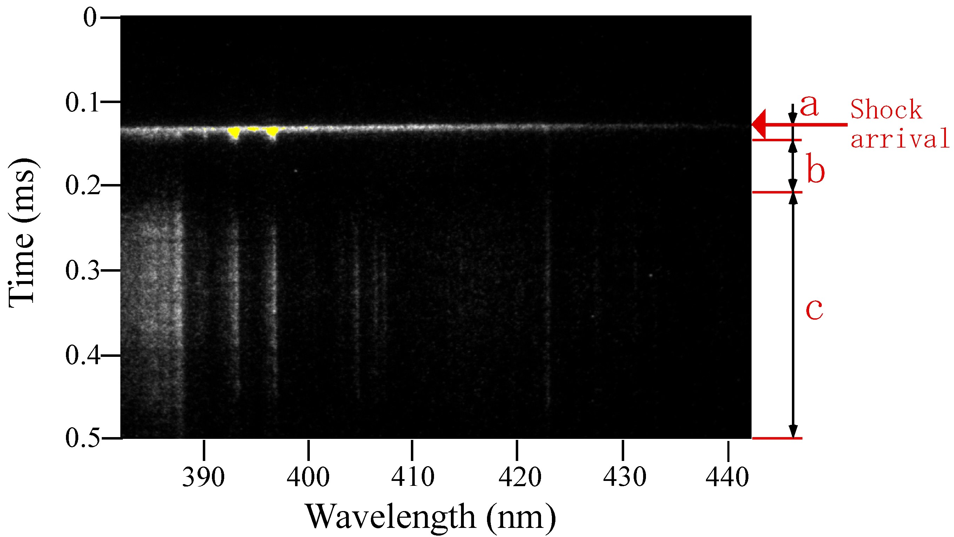
Fig1. Streak image
a : acceleration gas, b : test flow, c : expansion wave

Fig.2 Relative intensity history (red line) and static pressure

Fig.3 Photograph of radiation behind the shock wave

