Application of laser-induced liquid jet and shock waves to medicine
Makoto Komatsu
Water vapor bubble is produced by energy absorption of water. And large energy supply for a extraordinary short time brings about formation of underwater shock waves. Energy source for these phenomena is laser emission, electric discharge, explosive and so on.
In SWRC, production of bubble and shock waves in water with laser irradiation has been studied. Laser which has wavelength close to light absorption spectrum of water have to be employed as effective energy source. Holmium YAG (Ho:YAG) laser beam has 2.1 μm wavelength, which is close to 1.9 μm of a light absorption spectrum of water. Therefore, Ho:YAG laser is suitable to generate bubbles and shock waves in materials including a large amount of water.
Living body has large including ration of water. Hence, behavior of bubbles and shock waves in living body is similar to that in water. Based on these backgrounds, development of medical technique with laser-induced liquid jet and shock waves has been conducted for application of this novel to medicine.
Laser-induced jet is produced by laser emission in narrow capillary tube. Fig. 1 explains the process of laser-induced liquid jet production. Optical fiber is inserted into a capillary tube filled with water. Laser beam transmitted via the fiber produces water vapor bubble growing toward the capillary exit, and then water is expelled from the exit by expanding bubble. Water flow generated by the emanation of water produces liquid jet finally. Development of fibrinolytic treatment for cerebral arteries and surgical knives with the laser-induced liquid jet has been performed with Department of Neurosurgery, Tohoku University Graduate School of Medicine.
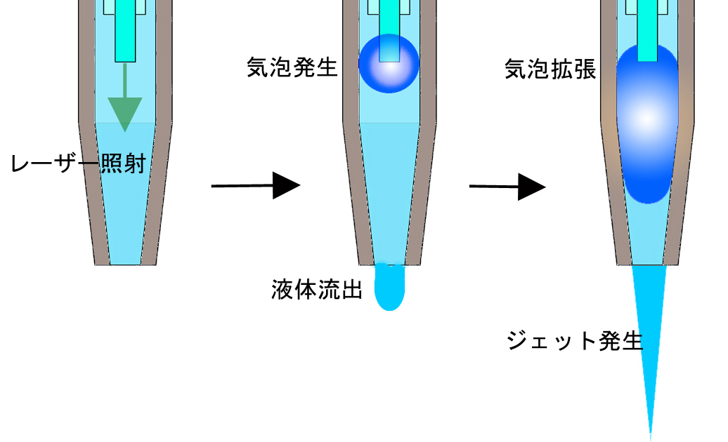

Fig. 1 Schematic description of laser-induced liquid jet generating process
Laser-induced liquid jet released from trial catheter, which is consisted of a catheter filled with water, Y-connector and optical fiber inserted into the catheter, was reacted to 10% w/t artificial gelatin thrombi. High-speed framing camera (SHIMADZU Co. Ltd.) captured jet penetration into the gelatin, and maximum penetration depth was measured from imaged results. From the observation (Fig. 2a), peak of maximum penetration was 9mm, which indicates that this system was effective on fibrinolysis, and distance between tip of optical fiber and exit of the catheter (D) had influence in strength of the jet (Fig. 2b). This means that the jet is controllable with D for various lesions.
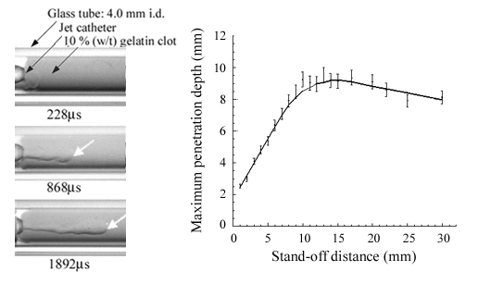
(a) (b)

Fig. 2 Jet penetration into gelatin artificial thrombus; (a) Time-resolved photographs of penetration, (350mJ/pulse of laser energy with 0.6mm core diameter optical fiber)(b) Relationship between D and maximum penetration depth.

A study aiming to development of surgical knives with laser-induced jet has simultaneously promoted. A copper capillary having taper nozzle at the tip was employed instead of abovementioned catheter, and trial jet surgical knife was made. Pig liver can be incised by using the jet knife preserving blood vessels (Fig. 3a). Ability of incision with the jet knife has been investigated by measurement of jet penetration into artificial internal organs made of 10% w/t gelatin (Fig. 3b).

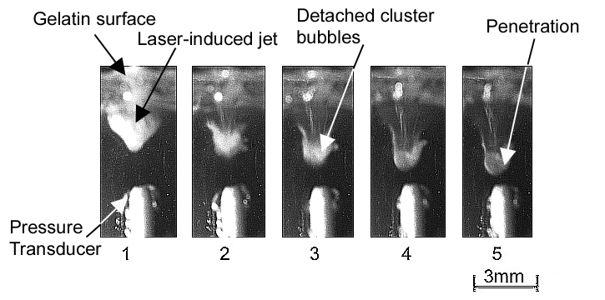
(a) (b)

Fig. 3 Application of laser-induced jet to surgical knives; (a) Incision of pig liver with trial surgical jet knife, (b) Time-resolved photographs of jet penetration into artificial internal organs (340mJ/pulse of laser energy, 64μs of interframe, 584μs of the lapse after laser pumping at the first frame).

Shock wave generation with laser-induced jet was observed in front of the exit of capillary tubes. The shock wave is caused by collapse and rebound of micro-bubbles. The micro-bubbles are created by interaction of laser-induced bubble with water, energy absorption of water existed outside of capillary and cavitation caused by vortex induced fast jet flow. Location and strength of shock wave depend on the cause of bubble formation and surrounding flow, therefore, parameter D and laser energy dominates them. Effectiveness of incision with shock wave against hard tissues was already confirmed by studies on ESWL. Hence, this shock wave can be utilized to the knife to cut hard tissues as calcified lesions. Besides, this system is superior to tissue damage, because there is no high temperature origin and construction is simple.
Contribution of shock wave to cut tissues and effect of shock wave on surrounding normal tissues are not revealed clearly. After this, Evaluation of them and optimization of abovementioned system are important subjects for clinical application.

