Study of Hypersonic Flow Fields over Double Cones
Kohji Naitoh

Recently, development of new space transportation system is enthusiastically conducted in the advanced nations. Perfect reusable space vehicles as single-stage to orbit and two-stage to orbit are investigated in this development, and accomplishment of numerical code based on real gas effects and simulation of the flow field over space vehicles using its code are required because of cutting development cost and environmental problem. So far several numerical codes based on real gas effects have presented, but enough results have not obtained yet because of the lack of reliable validation data. In recent years, double wedge model and double cone model are suggested as new validation models which sophisticate the numerical code, and the validation is enthusiastically conducted by comparing numerical results with experimental results. But enough results have not obtained yet because complex phenomena as shock/shock interaction, shock/boundary-layer interaction and separation of boundary layer exist in the flow field over these models and additionally most validation data were obtained in shock tunnels. In shock tunnel, vibration and dissociation of test gas occur in the nozzle reservoir and test flow is different from real flight condition. Therefore in case of using shock tunnel, evaluation of test flow should be conducted before getting validation data.
From these backgrounds, the objectives of this thesis are as follows,
- Evaluation of the test flow in a free piston shock tunnel belonging to Shock Wave Research Center (FPST).
- Qualitative analysis of the flow field over double cones.
- Acquisition of validation data.
Chapter 1 is introduction.

In chapter 2, evaluation of test flow in FPST was conducted by comparing the shock stand-off distances normalized by model radius in FPST with them in two stage light gas gun belonging to Shock Wave Research Center. The reasons for adopting this evaluation method are because close relationship between shock stand-off distance and real gas effects
Fig. 1 Comparison of normalized shock stand-off distance.
exists and hypersonic flights achievable
in a ballistic range would be produce a more reliable data than that in nozzle flow. In this comparison, a binary scaling parameter ρR was agreed with data obtained in both facilities. Figure 1 shows this result. Nozzle reservoir enthalpy in FPST is 4.8 MJ/kg and 10.4 MJ/kg respectively and both data was compared by based on stagnation enthalpy of free stream. In case of 4.8 MJ/kg condition, FPST data are good agreement with them in the ballistic range, but in case of 10.4 MJ/kg condition, both results disagree. Therefore we will obtain reliable validation data on 4.8 MJ/kg condition in FPST.

In chapter 3, qualitative analysis of the flow field over double cones was conducted. Semi-apex angle of first cone was fixed on 25 deg. and second cone semi-apex angle was varied between 40 deg. and 70 deg., especially detail analysis was conducted about second cone semi-apex angle 40 deg., 50deg., and 68 deg.. Visualization results, which were used in this analysis, are shown in fig. 2. In case of 40 deg. model, the flow field is steady and laminar flow, and real gas effects were not necessary to be considered. In case of 50 deg. model, the flow field became unsteady because the flow in a boundary layer transited to turbulent flow on the second cone. Additionally real gas effects should be considered. In case of 68 deg. model, the flow field became unsteady because separated boundary layer interacted with the transmitted shock and the flow in separation region oscillated.

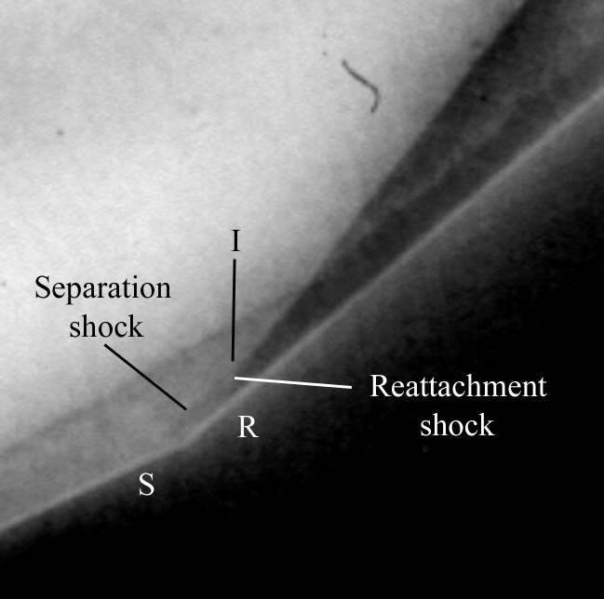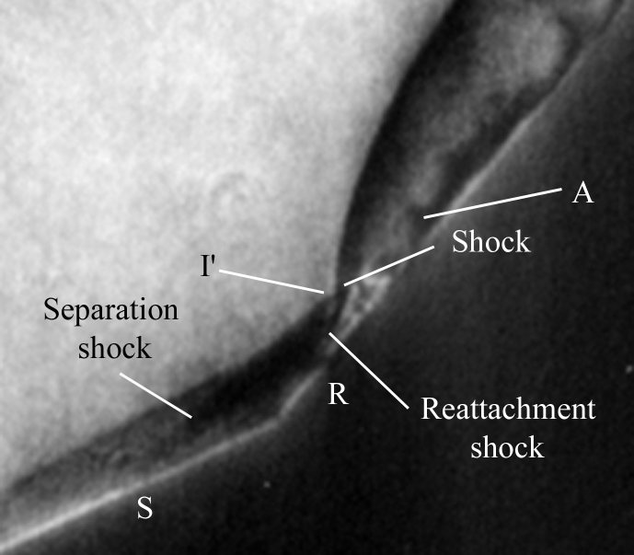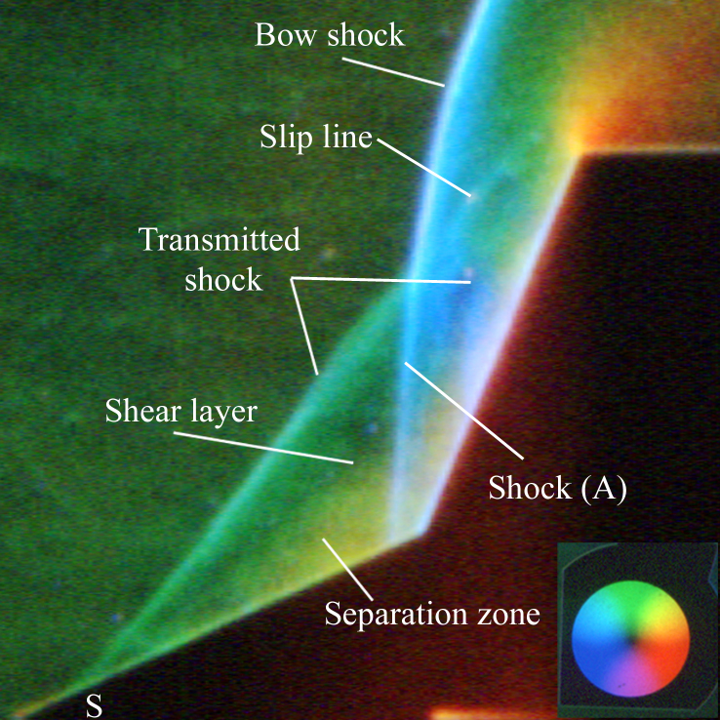
(a) (b) (c)

Fig. 2 Visualization results. (a) 40 deg. model; (b) 50 deg. model; (c) 68 deg. model.

In chapter 4, determination of density distribution of the flow field over a double cone and heat transfer measurements on the model surface were conducted in order to obtain validation data. The model semi-apex angle of first cone and second cone is 25 deg. and 68deg. respectively. This choice was based on the report that numerical results about this geometry were clearly different by using numerical code. In this study, both experimental results and numerical one were obtained, but the validation could not be conducted because the flow field was unsteady and comparing criterion could not be determined. So this validation is a future work.

Chapter 5 is conclusions.

