Study of Development of a Compact Two- Stage Light Gas Gun and its Ignition System
Masakazu Shinohara
- Background
The design of space debris bumper shields has become one of the most important research topics in the field of hypervelocity impact study and shock wave dynamics as well. In order to prevent from fatal damages possibly caused by such impacts, bumper shields has been proposed to protect the space vehicles from their penetrations. Oblique impacts are more probable cases depending upon the angle of orbital inclination between the space vehicles and the debris. In the Shock Wave Research Center (SWRC) of Tohoku University, we have previously tested with three impact angles, which revealed that the process of penetrations appeared to be significantly different upon the impact angle. This is a motivation of the installation of the compact two-stage light gas sun.
This facility is also planned to simulate large scaled impact phenomena which happened to occur 65 million years ago when asteroid impacted obliquely on earth. Authors believe that such a gigantic gas-liquid-solid impact should be experimentally and numerically simulated. Complex interactions of three-phase material should be examined from the point of view of impact study and also shock wave dynamics. The proposed facility accommodating such three-phase layers in horizontal position inside its test section can achieve oblique impacts.
On the other hand, a small facility has a fatal demerit in its synchronization with external systems such as visualization or other time controlling functions in operating with another gun or a shock tube. The duration time in which the projectile flies from the free flight chamber to the test chamber is too short to synchronize the visualization system. Therefore, the trigger signal has to be put in before the ignition. This mean that operation of two-stage light gas gun should be controlled time-accurately.

- Objectives
This study aims to examine the performance of compact two-stage light gas gun and to establish the novel ignition system which can control the gun operation time-accurately.

- Experiments and results
  - Velocity measurement
Projectile velocity was evaluated by changing the initial loading condition which affect the projectile velocity. Experimental condition and experimental result were shown in Table 1 and figure 1 respectively. Figure 1 shows that projectile velocity decreased as initial pressure of He increased. And higher projectile velocity was obtained by choosing a light-weight projectile made from high-density polyethylene and heavy piston.
Only 8 different velocities were measured by using heavy projectile and light piston. Therefore projectile velocities under the more detailed various initial conditions were predicted by using Random Choice Method (RCM). Figure 2 shows the velocity map by RCM and that relatively high projectile velocity can be obtained by relative small amount of propellant.

  - Time-accurate control of compact two-stage light gas gun
Novel ignition system was proposed and jitter of operation time was measured. Figure 3 shows the propellant chamber which uses the proposed ignition system. The chamber is filled with a stoichiometric oxy-hydrogen mixture gas. In this system, silver azide pellet is attached to the end of an optical fiber and is ignited by irradiation of a Nd-YAG laser pulse. The generated detonation wave travels along the chamber and ignites the silver azide pellets which arrayed linearly and explosion of pellets initiates the combustion of the smokeless powder. This system does not have black powder, so precise time control of the propellant combustion is possible. Figure 4 and figure 5 show an experimental setup and a typical result respectively. From 3 times experiment, projectile velocity of 5.12 ± 0.02 km/s was obtained. and it was found that the mean time interval between the trigger signal and the first pressure peak was 8.70 ms±128 μs, and the projectile passing signal of third laser beam was 10.07 ms±128 μs. This result means that projectile velocity was well reproduced but combustion of powder was not. However the mean time interval between the first pressure peak of combustion gas and the third projectile passing signal was 1.38 ms±6.44 μs. Pressure signal seems to be available to trigger the measurement device at test section.

- Concluding remarks
- Compact two-stage light gas gun can produce relatively high projectile velocity of 5 km/s with 30 g of propellant.
- Jitter time of powder combustion was large. However, piston and projectile motions were well reproducible. Therefore, the passage of combustion gas ca be used as trigger signal.

Table 1 Experimental conditions of velocity measurement
Powder weight [g] | Initial fill pressure of Helium [kPa] | Rupture pressure of first diaphragm [MPa] | Rupture pressure of second diaphragm [MPa] | Piston weight [g] | Projectile weight [g]
25 and 30 | 490～785 | 58.3 | 38.1～146.0 | 43.2 and 198 | 0.54 and 0.69
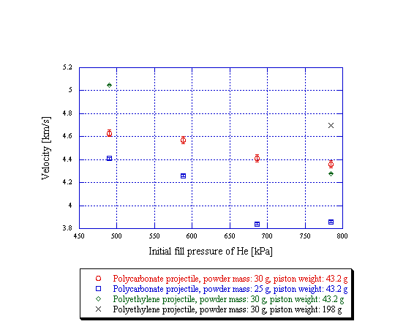

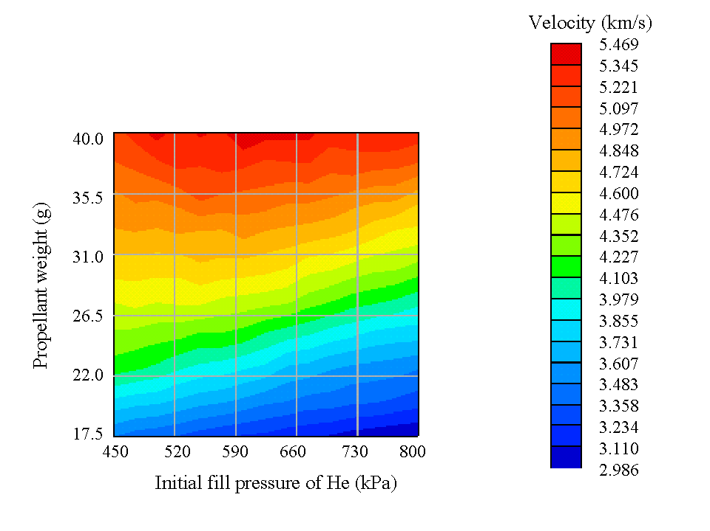

Fig. 1 Velocity profiles under various conditions Fig. 2 Velocity profile by RCM
propellant chamber body
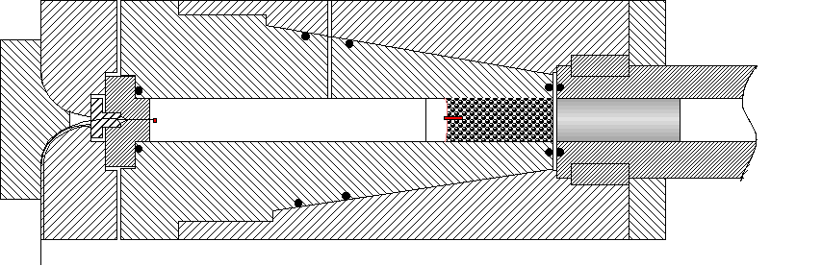

first diaphragm
piston
pump tube
port for filling oxyhydrogen mixture gas
powder inserting tube
smokeless powder
linear array of AgN₃ pellets
AgN₃ pellet
optical fiber without cover film

Fig. 3 Propellant chamber of compact two-stage light gas gun by laser ignition

GaAs semiconductor laser
free flight chamber
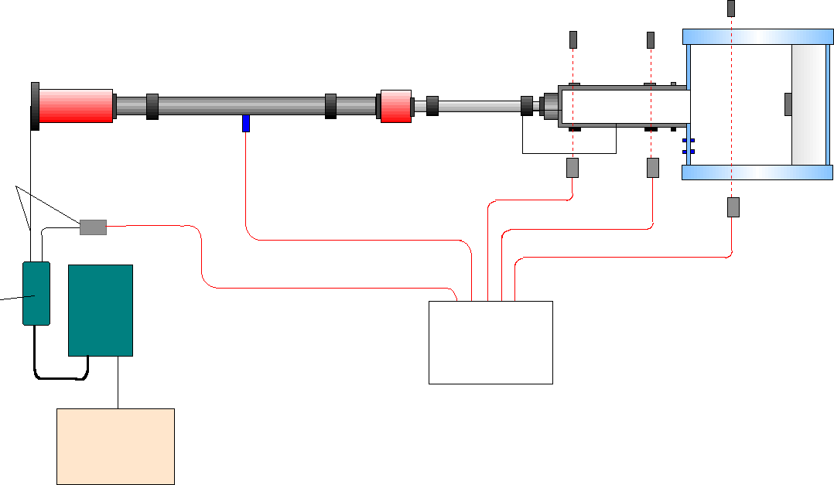
pump tube
launch tube
test chamber

pressure transducer
optical fiber

laser head
back plate
Nd-YAG laser power unit
pulse generator
digital memory
photo detector
photo detector

Fig. 4 Experimental setup of velocity measurement by laser ignition

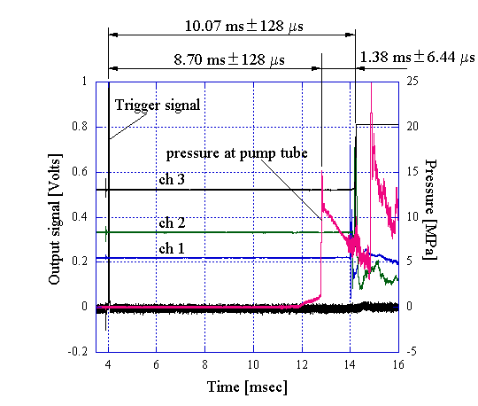
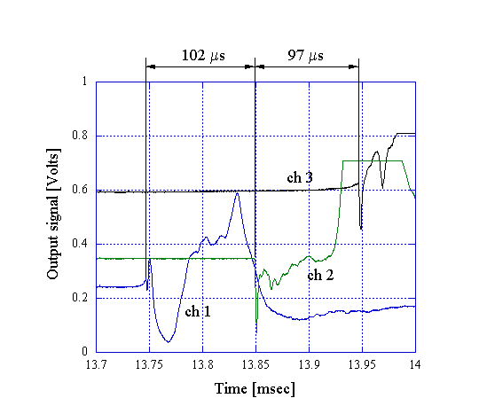

Fig. 5 Experimental result, projectile velocity: 5.12 km/s, test gas: air 2000 Pa

